Employee Attendance System:

UML DIAGRAM:

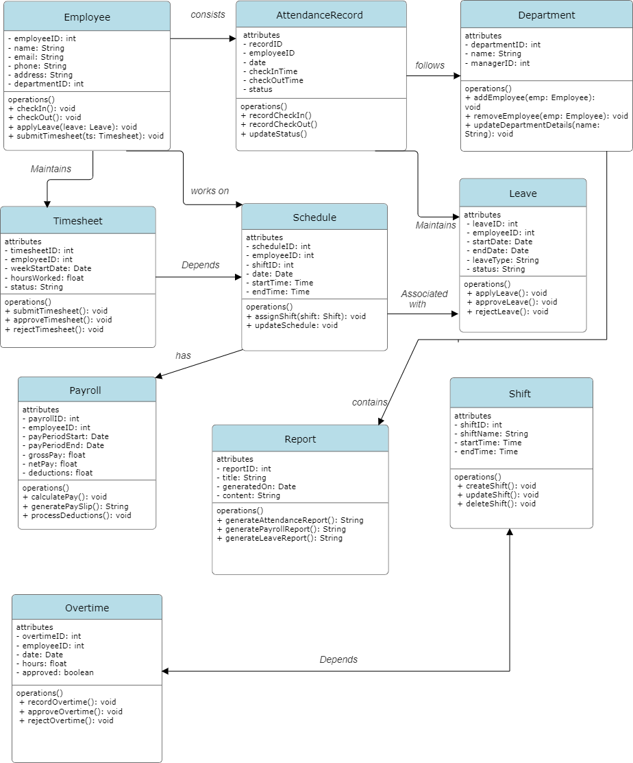

**Problem Statement:**

Our current attendance management approach lacks an integrated system to handle various aspects of employee attendance and related processes efficiently. This results in data redundancy, inconsistencies, and inefficiencies in managing attendance, leave, timesheets, schedules, payroll, and more. To address these challenges, we need to develop a UML diagram that accurately represents the relationships and dependencies among the following key attributes for the employee table:

1. **Employee**:
   * **Problem**: Employee data is scattered and not centrally managed, causing difficulties in tracking and referencing.
   * **Requirement**: A central entity representing employees, capturing essential information like employee ID, name, contact details, and position.
2. **Attendance Record**:
   * **Problem**: Manual attendance recording leads to errors and data loss.
   * **Requirement**: A system to automatically log employee attendance, with attributes such as date, check-in time, and check-out time.
3. **Leave**:
   * **Problem**: Managing leave requests and approvals manually is inefficient and prone to errors.
   * **Requirement**: An entity to track leave requests, approvals, leave type, and leave duration.
4. **Timesheet**:
   * **Problem**: Manual timesheet entry and validation are time-consuming and error-prone.
   * **Requirement**: A mechanism to record work hours, project allocation, and task details for each employee.
5. **Schedule**:
   * **Problem**: Scheduling shifts manually leads to conflicts and inefficiencies.
   * **Requirement**: An entity to manage employee schedules, including shift timings, workdays, and break times.
6. **Payroll**:
   * **Problem**: Inaccurate attendance and overtime tracking affect payroll processing.
   * **Requirement**: An integrated payroll system to calculate salaries based on attendance, overtime, and deductions.
7. **Department**:
   * **Problem**: Lack of clear departmental hierarchy and employee assignment.
   * **Requirement**: An entity to represent departments, with details on department name, head, and associated employees.
8. **Shift**:
   * **Problem**: Inconsistent shift management results in scheduling conflicts.
   * **Requirement**: A system to define shifts, including shift type, start and end times, and assigned employees.
9. **Overtime**:
   * **Problem**: Overtime work is not tracked accurately, leading to payroll discrepancies.
   * **Requirement**: An entity to record overtime hours, reasons, and approval status.
10. **Report**:
    * **Problem**: Generating comprehensive and accurate reports manually is labor-intensive and error-prone.
    * **Requirement**: A reporting mechanism to generate various reports on attendance, leave, overtime, payroll, and other metrics.